Course 12 Specialist Test 3 & Investigation 2

Test mark ______/24 Investigation mark ______/14

Student name: ________________ Teacher name: ________________

Task type: Response/Investigation

Time allowed for this task: 45 mins

Number of questions: 6 questions Test/ 1 question Inv

Materials required: Calculator with CAS capability (to be provided by the student)

Standard items: Pens (blue/black preferred), pencils (including coloured), sharpener, correction fluid/tape, eraser, ruler, highlighters

Special items: Drawing instruments, templates, notes on one unfolded sheet of
A4 paper, and up to three calculators approved for use in the WACE examinations

Marks available: 24 marks Test/ 17 marks Inv

Task weighting: Test 6 % Inv 8%

Formula sheet provided: Yes

Note: All part questions worth more than 2 marks require working to obtain full marks.

This first section will be recorded as test 3 in the assessment schedule.
Students decide how much time they will spend on each section, recommended 25 mins test & 20 mins Inv.

Q1 (3 marks)
Determine the equation of the tangent to at the point .

Solution
Specific behaviours
uses implicit diff using both quotient and product rules
determines dy/dx
states equation of tangent

Q2 (3 marks)
If determine an expression for in terms of .

Solution
Specific behaviours
uses product rule & implicit diff
subs dy/dx
obtains correct expression

Q3 (2 & 3 = 5 marks)
If and determine:
- in terms of .

Solution
Specific behaviours
determines rates of x and y in terms of t
determines dy/dx in terms of t

- in terms of .(No need to simplify)

Solution
Specific behaviours
attempts to diff dy/dx wrt to t
uses quotient rule correctly
divides by dx/dt

Q4 (4 marks)
Consider a metal sphere where the volume was measured and found to have an error of 5%. Use increments formula to determine the approximate percentage error in the radius.

Solution
Specific behaviours
uses increments formula
derives expression for %V
simplify in terms of %r
gives approx. % change

Q5 (4 marks)
Consider a triangle with angle radians and opposite side length cm, see diagram below. If the angle is changing at a rate of 3 radians/second, determine the exact rate of change of , when .

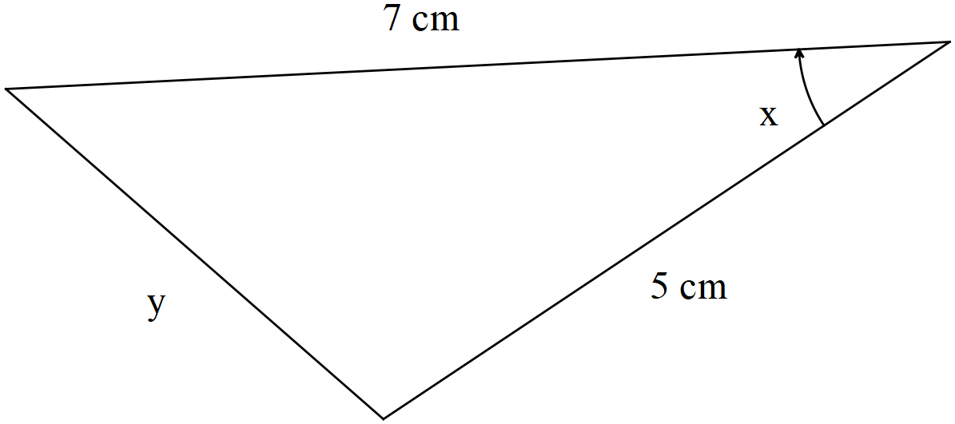

Solution
Specific behaviours
uses cosine rule
solves for y
obtains equation for time rates of x and y
determines exact expression for y rate

Q6 (5 marks)

Consider a car moving at metres/second towards a brick wall. On top of the car is a rotating light moving at an angular speed of radians/second. When the light ray hits the wall a spot of light can be seen moving along the line of the wall. Determine the speed of this dot of light on the wall when the light on top of the car is 12 m from the wall and the spot of light 5 m from the central point as shown on the diagram below.

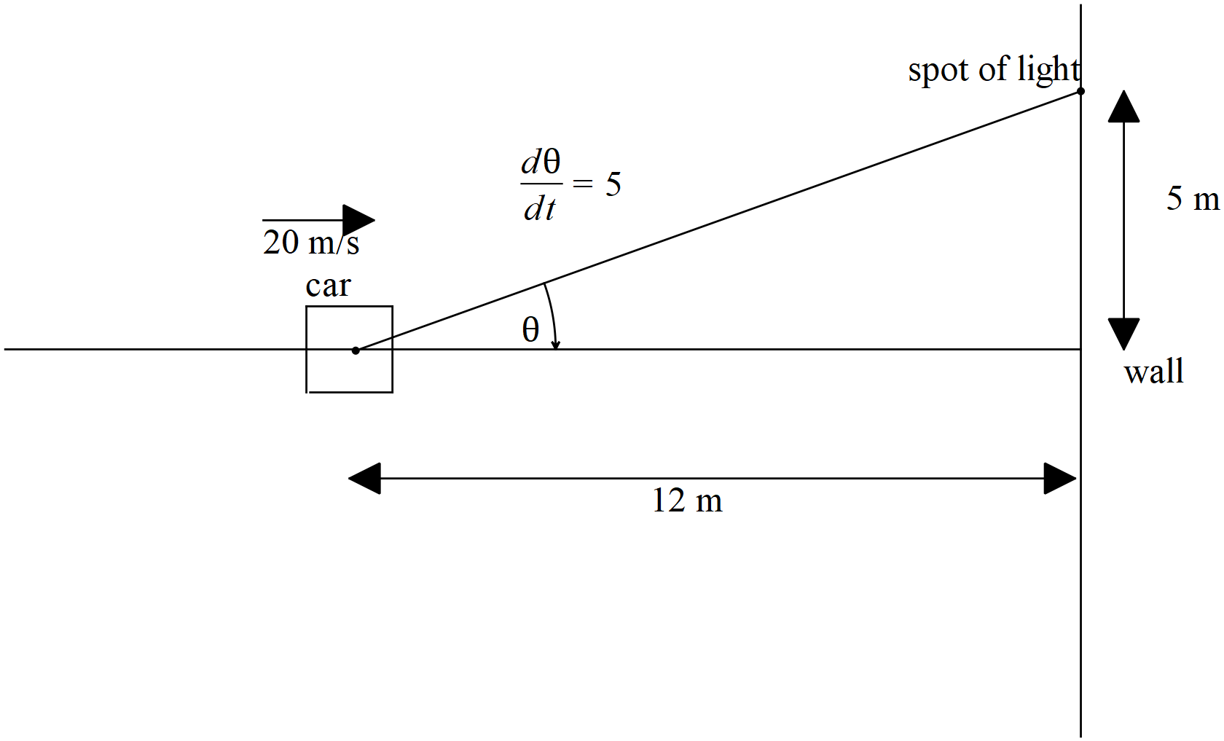

Solution

Also accept -78.75m/s if they have used negative angle rate!
Specific behaviours
uses a tangent function
uses product rule
diffs tangent function correctly
uses correct rates
determines approx. speed

Investigation section.

Q1 (3, 3, 4 & 4 = 14 marks)
Differentiate the following using logarithmic differentiation. Show all steps in this method.

Solution
Specific behaviours
uses log laws
uses implicit diff
obtains derivative in terms of x and y

Solution
Specific behaviours
uses log laws
uses implicit diff
obtains derivative in terms of x and y

Solution
Specific behaviours
takes log of both sides
uses log law
diff both sides
obtains expression for diff

Solution
Specific behaviours
takes log of both sides
uses log law
diff both sides
obtains expression for diff ( no need to simplify tanx term)

